# 500_Comparable Valuation Analysis

1. summary
   1. Comps modeling and analysis consists of two different approaches. The first is by looking at publicly traded peers to determine a value for a target company. The second approach is by looking at recent comparable transactions. The 2 different approaches will yield a different valuation, but the fundamentals are the same. I know how to value a company using multiples and how this type of valuation is different from a DCF.
   2. how do you think about the valuation?
      1. Valuation is the art and science of attributing a value to an investment. Investment can be anything from a company stock, asset, prospective projects, and real estate. It's important to know that valuation is not the same thing as price.
   3. Why value companies or assets?
      1. Valuation is probably the most crucial aspect of finance and is used in the processes below: Investment purpose, such as buy,sell or hold a stock; invest in a company project. Valuation is also used to determine corporate actions like making an acquisition or divesting a product line or business unit. Finally, valuation is also used for accounting. Certain accounting require a valuation.
   4. How many valuation techniques you can use?
      1. There are **3 main approach**. The asset approach, which focuses on the valuation of individual assets,often including the **cost** to build or the cost to replace, more common than the **asset** approach is the income approach, which is also know as an intrinsic valuation. The most common of which is a DCF . And finally, the **,market approach**, which is also known as a relative valuation.
      2. How many types of relative valuation
         1. The public company compables. The valuation based on the idea that similar public companies share similar risk and reward characteristics, and therefore should trade similarly. With precedent transactions, the valuation is based on the acquisition of companies similar to the target company. Regardless of the type, we calculate multiples, which are just ratios that scale companies for differences in size. We will discuss how we measure a company's size in a little bit, but we typically take the company size and divide it by a financial metric like EBITDA or earnings per share. Sometimes we divide size by a capacity factor, for example, an oil and gas company multiple might use reserves instead of earnings. One extremely important thing to note, precedent transactions usually result in higher multiples due to the presence of the control premium when a company is acquired.
      3. What is the adv and disadv?

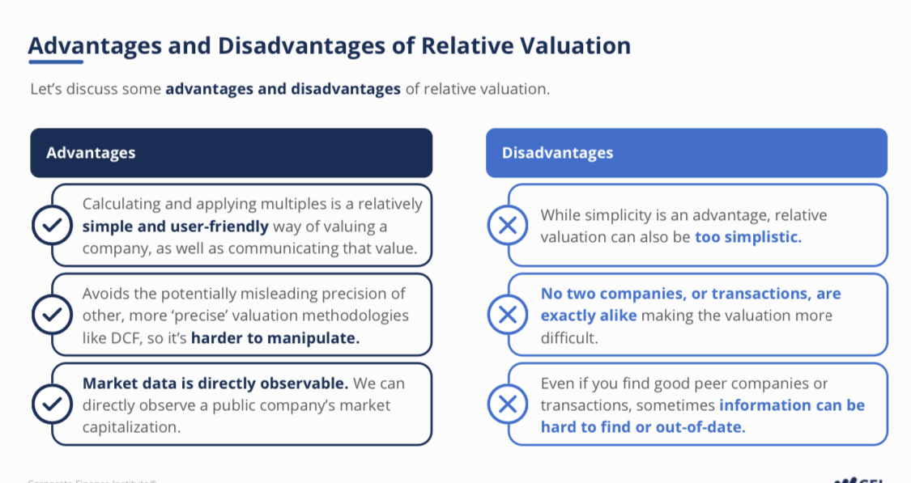

* 1. What is screening for comparables
     1. To value, we need to have a thorough understanding of the target's business, read materials as much as possible, including annual or quarterly filings the target makes, read equity and credit research, investor presentation, as well as listen to a company;s earnings conference calls. Pay special attention to the conference call Q&A as that gives you a better idea of what concerns or opportunities research analysts focus on. Once we understand the target's business, we can go through a **comparable company analysis**, which consists of **3 steps**: **select** appropriate peer companies. **Locate** and **enter** the relevant info into a comps model. **value** the target company using the selected multiples.

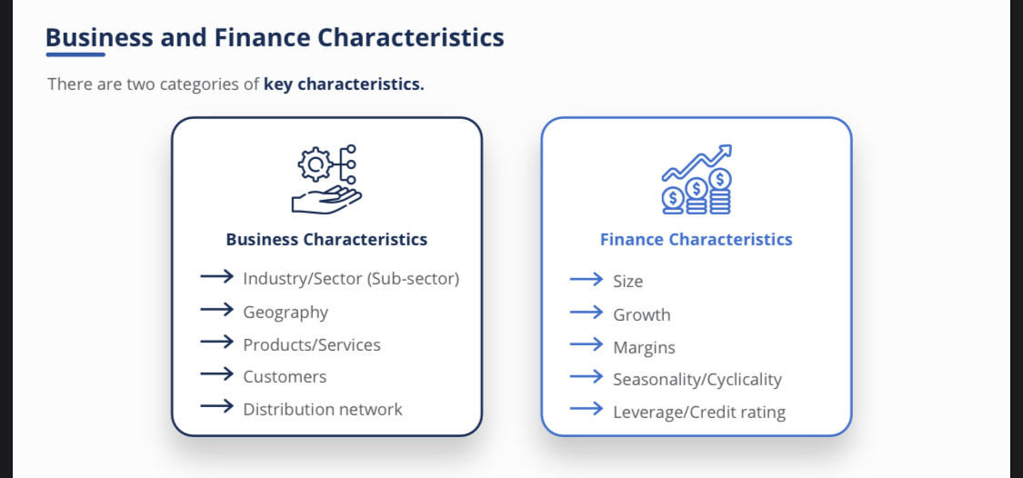

* 1. why perform a precedent transaction analysis
     1. We want to determine a hypithetical sales prices for a company. Especially if the goal of the analysis concerns either a sale or an acquisition. We also use **transaction comps** as a comparison against the other main valuation methodolgies like **trading comps** and **discounted cash flow**.

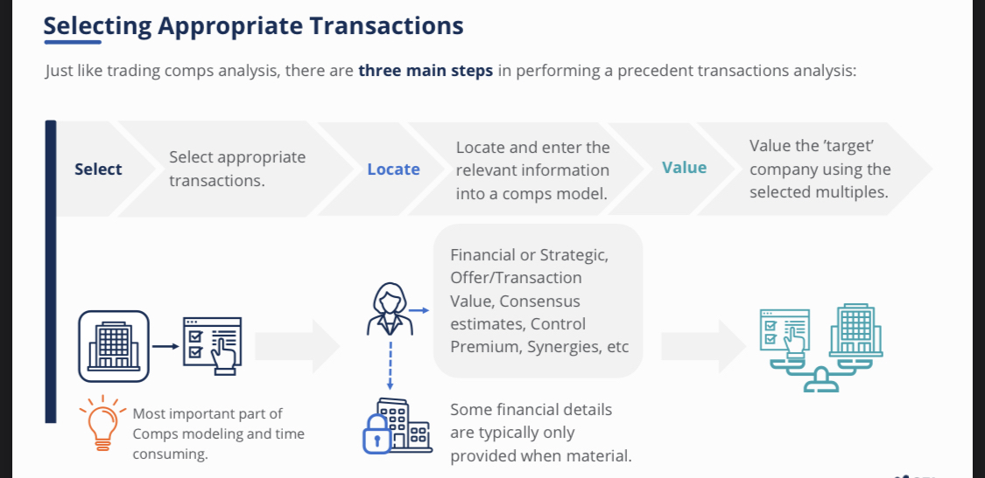

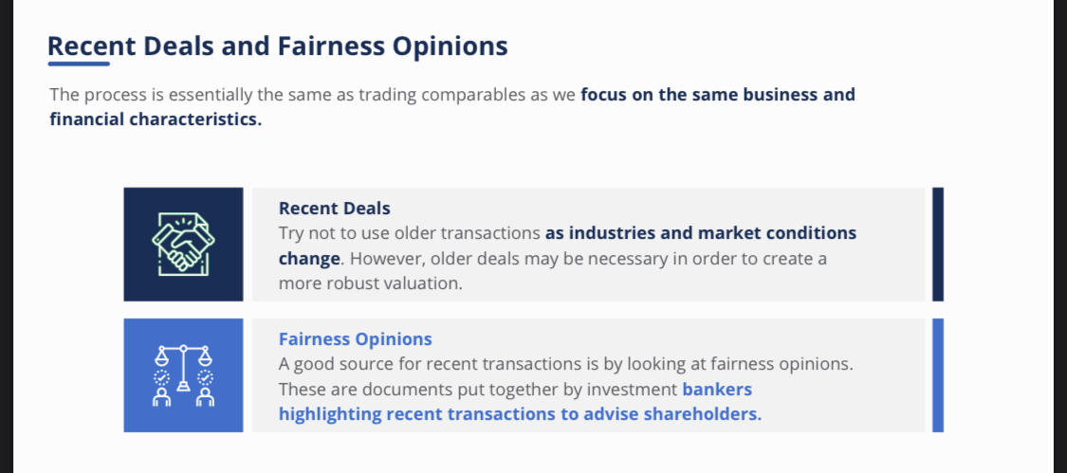

* 1. what is enterprise value?

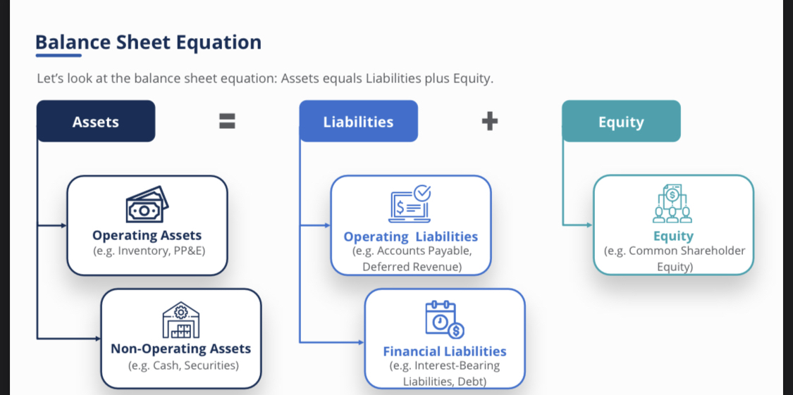

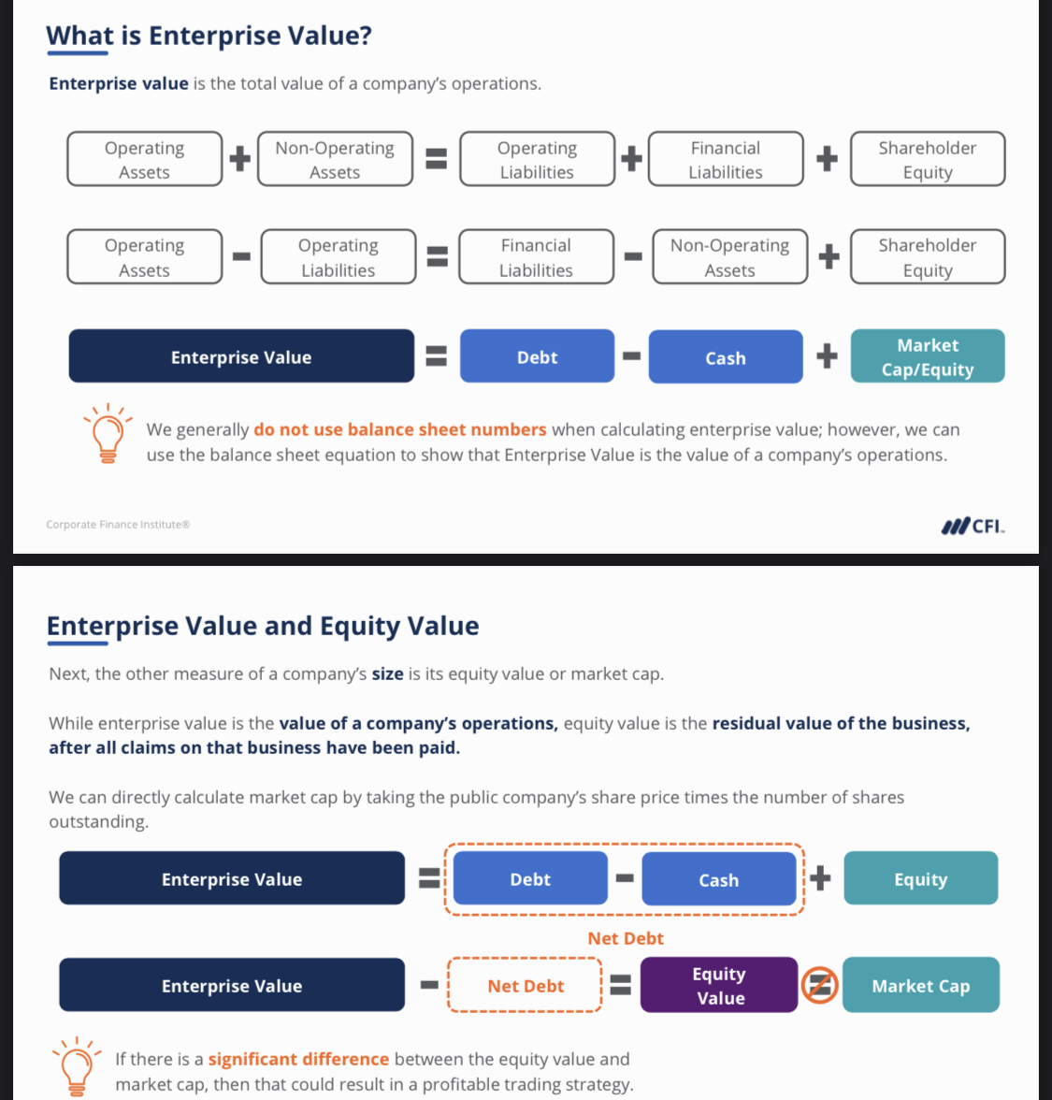

* 1. Debt and Debt Equivalents
     1. Debt is **interest-bearing** and generally has a **higher 'claim' on a company's business** than any other source of funding.This is important because **debt gets paid first** before other funding sources.
  2. Lease and Preferred Stock
     1. A debt equivalent is **leases**.
        1. Currently, nearly all leases, whether classified as a finance or operating lease, are recognized on the balance sheet. There will be a right of use asset, offset by a corresponding lease liability. One way to think about a lease is a company purchasing a piece of equipment by issuing debt. This debt has an implicit interest rate, so we should consider leasing a form of collateralized borrowing. Please note there is a key difference between how US GAAP accounts for operating leaves versus companies using IFRS. Under IFRS, lease expense is broken up into an interest expense and a depreciation expense component. Remember a lease is essentially a collateralized borrowing, so this treatment should make sense. However, under US GAAP, only a finance lease has the same accounting as IFRS. For releases that are considered operating, US doesn't seperate lease expense into interest and depreciation, but the period's rent expense is in one expense and it reduces EBITDA. This presents some comparabilities issues between IFRS and GAAP. Therefore, if we want to compare a US GAAP company with an IRFS company, we need to add back operating leases expensed as rent, results in numerator denominator consistency since lease will be a debt equivalent in the numerator of enterprise value.

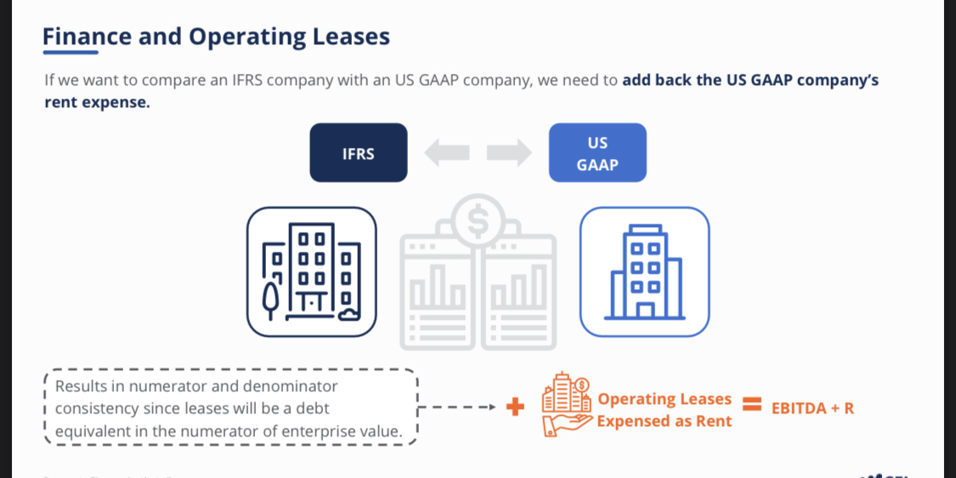

* + 1. Preferred stock
       1. it is essentially **a hybird debt and equity security**. It is a higher claim in common shareholders and a preference on dividends. It is considered a debt equivalent for evaluation purposes and included in net debt.
    2. Non controlling interest(NCI)
       1. Although NCI typically shows up in a shareholders equity on a balance sheet, it is not considered common equity and should be included in net debt as a debt equivalent. NCI is created when a company owns greater than 50% but not 100% of a subsidiary. Since the company effectively controls the subsidiary, the company will prepare conslidated financial statements.
  1. Tesco
     1. #shortcut shirt Ctrl F 可以用于快速查找
     2. #shortcut ctrl shift N可以用于具体的页数
     3. Cash and Non-cash operating assets
        1. list of cash and non-operating assets
           1. Cash and cash equivalents cash on hand, as well as forms of cash like readily convertible deposits, un deposited checks, money orders, and deposits in banks. Marketable or liquid securities generally represents excess cash that has been invested in government securities, or corporate debt and equity securieies. Sometimes a company will decide to dispose of an asset, it will usually set up an account called assets held for sale. Since this asset is in the process of being sold, we tipically consider this a non operating asset. Finally, an investment in an unconsolidated affiliate coours when a company has significant influence over another company, the affiliate, but it doesn't control the affiliate. This is typically defined as owning between 20% and 50% of the other company. 现金及现金等价物 库存现金，以及随时可兑换的存款、未存款支票、汇票和银行存款等形式的现金。有价证券或流动证券一般指投资于政府证券或公司债券和股权证券的多余现金。有时，公司会决定处置一项资产，通常会设立一个名为待售资产的账户。由于该资产正在出售过程中，我们通常将其视为非经营性资产。最后，对非合并关联公司的投资是指一家公司对另一家公司（即关联公司）有重大影响，但并不控制该关联公司。这通常被定义为拥有另一家公司 20% 至 50% 的股份。
     4. unconsolidated affiliates非合并联营公司
        1. Investments in unconsolidated affiliates
           1. When there is an unconsolidated affiliate, the company does not actually record the affiliate's assets and liabilities on its balance sheet. It's basically the opposite of consolidation and non controlling interest. The company simply recognizes a non current investment. The company is entitled to a proportionate share of the affiliate's income, which it recognizes on the income statement, usually below operating income.Therefore, to maintain numerator denominator consistency, we deduct the investment as a non operating asset in out enterprise value net debt calculation. Due to lack of information and disclosure, we typically use the book value of affiliates. 当存在非合并关联公司时，公司实际上不会在资产负债表中记录关联公司的资产和负债。这基本上与合并和非控股权益相反。公司只是确认一项非流动投资。因此，为了保持分子分母的一致性，我们在计算企业价值净债务时将该投资作为非经营性资产扣除。由于缺乏信息和披露，我们通常使用联属公司的账面价值。
  2. Income statement and last non-operating assets
     1. Income statement data
        1. After knowing the company size(enterprise value and equity value), then we can calculate the appropriate financial metrics for our multiples. While there are many types of multiples, we will focus on Enterprise Value to EBITDA and share price to earnings per share ( PE ratio).
     2. Forward Estimates
     3. Unlevered vs levered metrics
        1. Unlevered : any financial metric before interest expense.
        2. levered: any financial metric after interest expense.
        3. Normalization

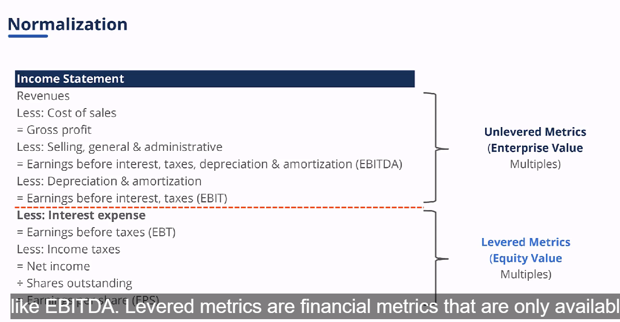

* + 1. Adjustments and Estimates

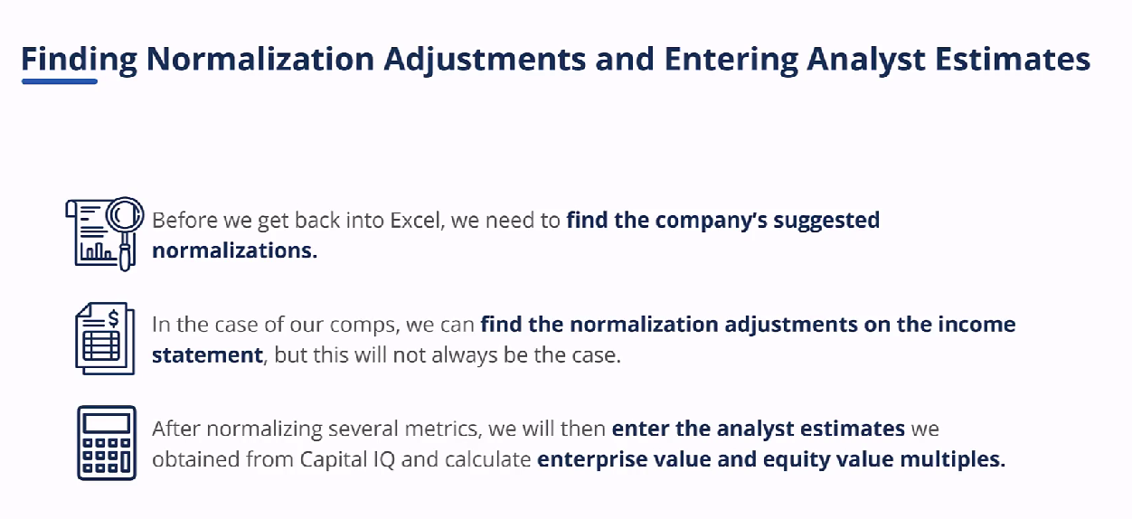

* 1. Normalization
     1. After entering the income statement data and calculating LTM, we need to normalize these numbers. We want to remove any nonrecurring, unusual gains or losses the company reports. So analyst will need to use their judgement on what to include when normalizing a company's financials. Having said that, most analysts will try to match the company reported adjustments, which is what we will do shortly.
     2. 在输入损益表数据并计算出LTM后，我们需要对这些数字进行归一化处理。我们要剔除公司报告中的任何非经常性、非正常损益。因此，分析师在对公司财务数据进行归一化处理时，需要根据自己的判断来确定包含哪些内容。尽管如此，大多数分析师都会尝试与公司报告的调整相匹配，这也是我们即将要做的。

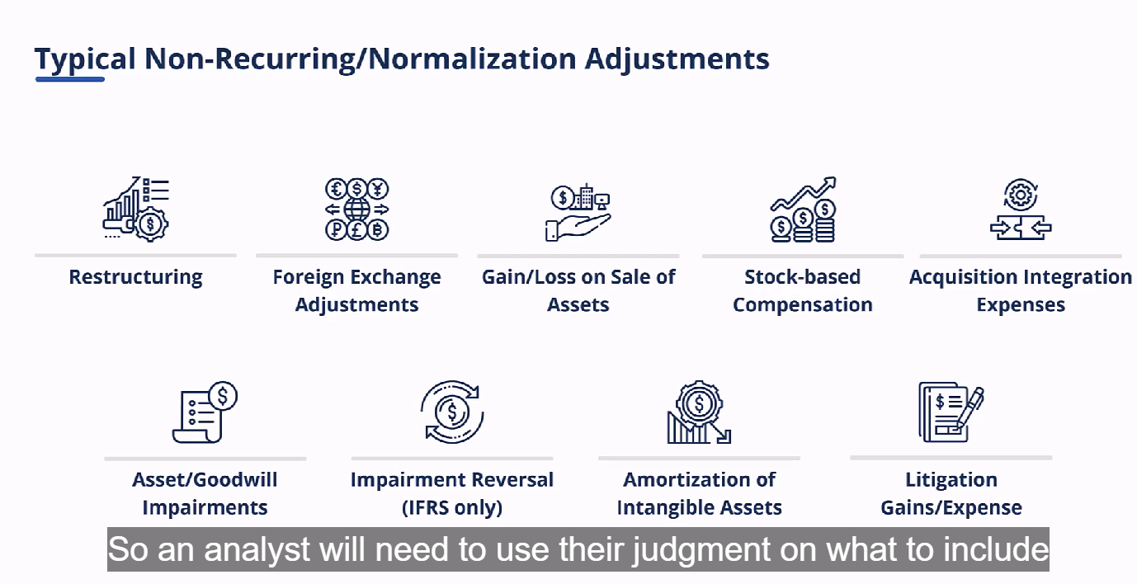

* 1. Fully Diluted Shares Outstanding 完全稀释总股数
     1. Basic vs. Diluted Shares Outstanding
        1. we need to calculate a company's true market cap, then discuss the number of shares a company has or may have. ANALYSTS PREFER FULLY DILUTED SHARES OUTSTANDING AS THIS **captures all potential shares**. A fully diluted share account is the basic share account, **plus any potentially dilutive securities**. 完全稀释的股票账户是基本股票账户加上任何可能稀释的证券, which com form employee stock options股票期权, warrants认股权证, restricted stock限制性股票, or other share awards股份奖励, or convertible debt可转换债务 or convertible preferred stock可转换优先股.
     2. Stock option basics
        1. Employees are given stock options to help incentivize them. These stock options have a strike or exercise price that the employee pays to receive the number of shares in the options agreement. And employee would only exercise the option if the exercise price is less than the company's market price. 授予员工股票期权有助于激励他们。这些股票期权有一个行权价或行使价，员工支付了行权价就可以获得期权协议中规定的股票数量。 只有当行使价低于公司市价时，员工才会行使期权。
     3. Options and Warrants
        1. when calculating the number of options to include in the fully diluted share account, we typically use a calculation known as the **treasury stock method**. The treasury stock method assumes that any proceeds the company from the employee will be used to **repurchase shares at the current market**. 在计算完全稀释股份账户中应包含的期权数量时，我们通常使用一种称为库存股法的计算方法。 库存股法假定公司从员工处获得的任何收益都将用于在当前市场上回购股票。There for, **the impact from dilution is the number of in the money options given to the employee less any shares repurchased by the company**. we **should include any unrecognized compensation cost** as proceeds but we don't typically have enough information to do so.因此，稀释所产生的影响是给予员工的现金期权数量减去公司回购的任何股份。我们应将任何未确认的补偿成本计入收益，但我们通常没有足够的信息来这样做。
     4. Restricted Stock and Other
        1. we should also used the treasury stock method for a restricted stock or other share awards. While there is no exercise price, the employee must pay, the hypotheticalal proceeds = the unrecoginized compensation costs related to RSAa /RSUs.对于限制性股票或其他股票奖励，我们也应采用库存股法。虽然没有行使价，但员工必须支付，假设收益 = 与 RSAa /RSU 相关的未入账补偿成本。 we typically add unvested restricted stock or other stock awards directly to the basic share count to derive the diluted share count.我们通常将未归属的限制性股票或其他股票奖励直接加到基本股票数量中，以得出稀释股票数量。
  2. Trading Comps Summary
     1. comparable companies
  3. Precedent Transaction Nuances先例交易的细微差别
     1. while the process behind selecting precedent transactions vs. public company comps is similar, there are several additional data points and calculations we need to consider.虽然选择先例交易与上市公司比较的过程相似，但我们还需要考虑几个额外的数据点和计算方法。
        1. we always want the deal announcement date as well as the deal status, whether it is just been announced, pending , the deal is closed ,the deal has been withdrawn. we need the target's share price if the target is public, but we also use the acquirer's share price if applicable. Merger consideration can come in either stock, cash or a combination of cash and stock. 如果目标公司是上市公司，我们需要目标公司的股价，但如果适用，我们也需要收购方的股价。 合并对价可以是股票、现金或现金与股票的组合。
     2. Merger consideration
        1. The simplest structure is an **all cash offer**, in this case在这种情况下, the acquirer makes a cash offer提出现金收购 for all of the targets 目标公司outstanding shares所有已发行股票, assuming 假定the target is a public company. To get the total consideration总对价, we multiply the per share每股 cash amount现金数额 by the target's share count乘以目标公司的股份数. If the target is private then the all cash offer全现金收购要约 will be a lump sum amount一笔总金额.
           1. 最简单的结构是全现金收购，在这种情况下，收购方对目标公司所有已发行股票提出现金收购，假定目标公司是一家上市公司。为了得到**总对价**，我们用**每股现金数额乘以目标公司的股份数**。如果目标公司是私营企业，那么全现金收购要约将是一笔总金额。
        2. In an **all stock offer**全股票收购, then the acquirer, if public如果收购方是上市公司, will usually use **an exchange ratio**交换比率, which is the ratio of the acquirer shares收购一部分的收购方发行股票 to be issued as part of the acquisition to the number of target shares to be acquired被收购目标股票数量. While there are different ways to structure an exchange ratio交换比率的结构, we will assume it is a fixed exchange ratio. We can multiply the exchange ratio交换比率 by the acquirers share price收购方的股价 to obtain the value of the stock股票价值 the target will receive目标公司将获得.
           1. 在全股票收购中，如果收购方是上市公司，通常会使用交换比率，即作为**收购一部分的收购方发行股票**与**被收购目标股票数量的比率**。虽然交换比率的结构有不同的方法，但我们假设它是一个固定的交换比率。我们可以用**交换比率乘以收购方的股价**，得出**目标公司将获得的股票价值**。
        3. In a mixed offer, we have to account for both the cash consideration and the stock consideration.
     3. Premiums paid analysis 支付溢价分析
        1. If the target is public, we also want to know what the premium paid might be. A premium is paid in order to acquire control of the target. If no premium was offered, then selling shareholders 出售股东would have no incentive to sell没有出售的动力. This premium is expected by both the acquirer and target and is a common measure in M@A and precedent transactions. 如果目标公司是上市公司，我们还想知道支付的溢价可能是多少。支付溢价是为了获得目标公司的控制权。如果不提供溢价，那么出售股东就没有出售的动力。收购方和目标公司都希望获得溢价，这也是 M@A 和先例交易中常用的衡量标准。
     4. Timing consideration
        1. With precedent transactions, we need to be aware of timelines, unlike trading comps交易比较不同. An offer to acquire a company is made收购一家公司的要约已经提出, but the transaction won't close交易还不会完成 for some time after the announcement and the signing of the merger documents宣布和签署合并文件后. Because of this, an analyst must make a judgement call on what information to use based on timing. For the purposes of our transaction comp为了进行交易比较. we're gonna use the data available 可用数据when the auction was held 拍卖时to calculate the offer value and transaction value要约价值和交易价值. For the premiums paid analysis, we also have to make a judgement call. " Do we use the dates when the original offer was made 我们是使用最初报价的日期or the final offer?使用最终报价的日期" .
           1. 对于先例交易，我们需要注意时间安排，这与交易比较不同。收购一家公司的要约已经提出，但在宣布和签署合并文件后的一段时间内，交易还不会完成。因此，分析师必须根据时间来判断使用哪些信息。为了进行交易比较，我们将使用拍卖时的可用数据来计算要约价值和交易价值。对于已付溢价分析，我们也要做出判断。"我们是使用最初报价的日期，还是使用最终报价的日期？我们的先例交易是私募股权公司 CD&R 收购 Morrison 超市。我们的先例交易是私募股权公司 CD&R 收购 Morrison 超市。